[1]

Gender Classification from Iris using Machine Learning Techniques

Kedar Amrolkar Arpita S Tugave

*Computer Information and Science* *Electronics and Computer Engineering*

University of Florida

Biometric and Pattern Recognition

December 7, 2015

***Abstract*—The increase in the applications of biometric system, demands for a better performing system. Classification of biometric traits reduces computation and boosts performance. Iris is one of the most accurate and reliable biometric trait. Gender classification and identification of Iris is an advancing topic. With reference to previously studied methods, this paper presents with an improved algorithm for iris gender classification. Usage of ULBP and GRAB has been explored. We believe our method will achieve accuracy, higher than previously achieved till date. This suggests scope for further improvement.**

***Index Terms*— Local Binary Pattern (LBP), Generalized Region Assigned to Binary (GRAB), Local Phase Quantization (LPQ), Support Vector Machines (SVM), K-Nearest Neighbor (KNN), Ensemble, ADA boost and Decision tree.**

1. INTRODUCTION

Biometric systems are used in the Identification or Verification using various biometric traits. Namely: fingerprint, face, iris are used as biometric traits. Experiments suggest: iris performs better; achieving higher verification accuracy over other traits. This can be attributed to distinctive Iris textures. Also, very little variations in Iris over the lifespan, contributes to it being a strong biometric trait. Protected by the cornea, iris is surrounded by sclera on outer side and pupil from inner side. Human eye anatomy and Embryology research may help us understand iris. Prominent ring in the iris of Asians is used in ethnicity classification. For gender, studies suggest that female iris is shorter in diameter to male iris. Such factors could contribute to significant textural differences between the male and female iris.

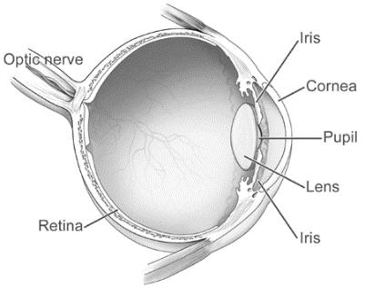

Fig. 1.Human Eye Anatomy.

Classification of Biometric traits is one of the most sought out problem. In recent days, with an increase in population, efficient algorithms and reducing storage are of utmost priority. With gender classification, we can achieve a biometric system which searches only half the database. Reduction in search space helps in reducing computations. Also, in a crime scenario, gender classification helps in reducing target suspect space. Additionally, Use of face for gender classification can be seen in the user interface, marketing, surveillance. But, gender classification of iris still has a long way to go. Iris as a biometric system is more reliable than face. Thereby, in future iris gender recognition system, possibly could replace face gender recognition systems. The detailed study of such a system is necessary to bring it to a real world platform**.** Therefore, identifying soft biometrics like gender, ethnicity, using iris is an emerging research area.

This paper is our first attempt to classify iris images. Firstly, considering gender classification, we experimented with various feature extraction techniques, machine learning classifiers and feature fusion techniques. Finally, we present an improvised feature extraction algorithm for iris. We found this algorithm to produce better accuracy in gender classification than previously suggested algorithm by Tapia et al. [3] for selected database. This paper is directed towards readers trying to extract more information from texture similar to iris. Also, for readers who are working on classification using iris or related trait may find this paper useful in their research. Many figures have been presented for better understanding.

* 1. *Previous Work*

Not much work has been done to classify iris. There are only a handful of research papers, and most of them focus on ethnicity. First paper on gender classification of iris by Thomas et al. [4] used iris texture along with its geometric details. After iris normalization of images captured using LG 2200, log–Gabor filtering is applied to achieve prediction accuracy of 80%.

Second paper on iris was by Lagree et al. [2]. They were the first to implement part-wise texture extraction. But they could achieve only a 62% for gender prediction; however an 80% for ethnicity prediction. Third paper on iris gender classification by Bansal et al. [1] used SVM classifier with Gaussian kernel function on statistical features. Even though they achieved 83%, their database was too small of only 800 images.

Recent paper by Tapia et al. [3] achieved accuracy of 91% for iris gender prediction. They used ND-Iris Database which uses LG 4000 imaging system with NIR illumination. Their data composed of 3000 images with equal right and left iris of each subject. Using several variants of LBP, finally they showed ULBP with 50% overlap producing the highest accuracy of 91%.

Paper by Sapkota et al. [5] presented a feature extraction technique called GRAB. It consists of a LBP variant applied over a series of blurred images. This technique displayed improved performance over LBP and its variants.

We experimented with the results from Tapia et al [3] and Sapkota et al [5] proving the result pattern applies to our data. Then we combined both the ideas, producing a novice algorithm.

1. METHOD

Classification of iris involves four major steps. As shown in Fig. 2, we first capture iris images. In ND-Iris database, eye images are captured using LG2200. Then iris segmentation is performed. There are various ways in which iris is localized. Some to name: Integral differential operator, Hough transforms. After experimenting with several segmentation algorithms such as: Masek[10], Iris BEE software[11], USIT software[8]; the ‘Weighted Average Hough and Ellipsopolar Transform’[12] from USIT was adopted. Extraction of features is vastly studied and best algorithm is chosen. An SVM classifier with linear basis function produces the best result.

Capture image

Segment iris

Extract features

Classify

Result

Fig. 2. Steps to Classify Iris.

* 1. *Iris Segmentation*

For iris segmentation, we use USIT software provided by the University of Salzburg. This particular Toolkit comes with two segmentation implementations. By observation, we found Weighted Adaptive Hough and Ellipsopolar Transform–WAHET to suit our data better. Detailed information on this can be found in reference [12]. This two stage segmentation, finds the pupillary and sclera boundary separately. Then, iris is transformed from polar to Cartesian coordinates, producing rectangular 30 x 360 iris texture. Let us first discuss iris localization, then unwrapping.

First in the iris localization technique, iris center C is found using weighted adaptive Hough transform with multiple resolutions. This is deemed to be independent of database. Thereby, comparatively, WAHET segments iris better even with off–angle position of iris. Next, polar transform is used to find pupillary boundary. Edge points are fitted by an ellipse. Following, the second boundary of sclera is found using Ellipsopolar transform. It is seen that second ellipse boundary is concentric to first boundary ellipse. The last part of iris localization uses adaptive thresholding, region size filtering and morphological dilation to remove reflections inside the pupil. Iris localization is shown in Fig. 3.

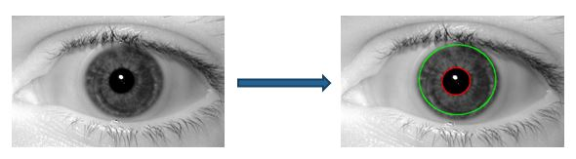

Fig. 3.Iris Localization.

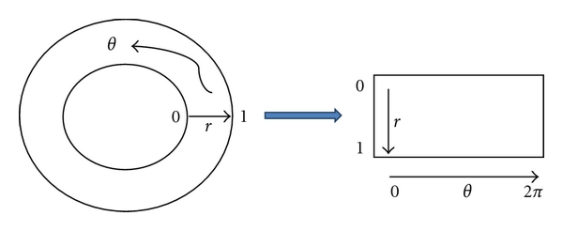Fig. 4.Daughman Rubber Sheet Model.

Iris unwrapping is transforming iris from polar to Cartesian coordinate system as shown in Fig. 4. The resulting Cartesian template is known as Daughman rectangular rubber sheet model. Different segmentation algorithms produce different dimension of rubber sheet texture templates, by using interpolation. Texture template (Fig. 5. First and Third row) used in our experiments, have a width of 360 and height of 30 pixels. This helps us in windowing size of 10x10. Further, you can see eyelashes and eyelids in iris template. Classifying iris with these obstructions may affect output. Therefore, efforts are made to mask these obstructions out by calculating the average positions of eyelids and eyelashes (Fig. 5.Second and Last row). This gives us original and masked texture set.









Fig. 5. Top two rows: Original data, Bottom two rows: Masked data.

## Feature Extraction Techniques

1. *LPQ –Local Phase Quantization*

LPQ, a grayscale image operator utilizes phase information over magnitude information. As the magnitude of pixel varies with blur and illumination, phase tends to stay constant. Daughman used Gabor wavelets to extract phase information. On similar lines, Local Phase Quantization was introduced by Ojansivu et al. [9].

Local Phase Quantization is mainly used for sharp variation of textures. It has shown higher performance over Local Binary Pattern in face classification. But in the iris, texture varies smoothly. Therefore, LPQ fails to perform better than other existing feature extraction techniques like Local Binary Pattern.

1. *LBP –Local Binary Pattern*

Local Binary Pattern or LBP is a local feature extraction technique like LPQ. Applications of LBP are researched in [13], [14], and [16]. A characteristic feature of LBP is its dependence on the neighboring pixels. In evaluating LBP, 8 surrounding pixels of one selected pixel are considered*.* Traditional LBP is signed Compound–LBP. That is, neighboring pixels are compared in magnitude with pixel at the center.

Let the value of center pixel be *gc* and the value of corresponding 8 neighboring pixels be *gp*. Let *s*(*x*) be 1 if *x* ≥ 0 else 0. Then,

The LBP value is observed to lie in the range of 0 to 255. Taking histogram, we can reduce dimension to 1 x 255. Such an instance of histogram is shown in Fig. 8.

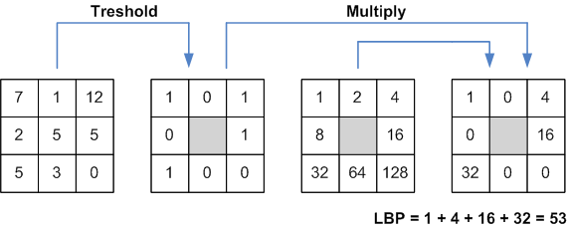

Fig. 6. Local Binary Pattern.

The local binary pattern is useful to find textures such as edges, corners and other non-uniform variations (Fig. 7.). As iris is textural variation of various ridges and rings, LBP can extract these variations easily. Also, LBP being a strong local extractor is best suited to extract maximum features of iris local textures.

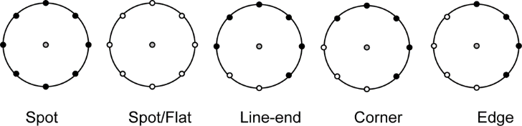

Fig. 7. LBP signed variation.

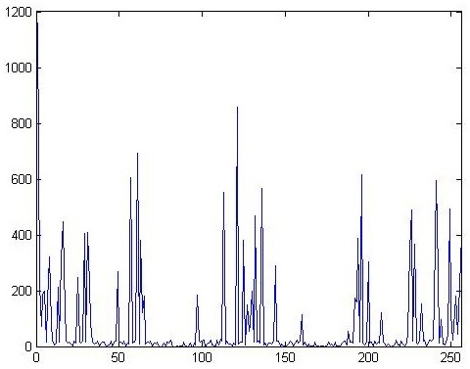

Fig. 8. Instance of Histogram used in LBP

Another variant of LBP namely compound local binary pattern–CLBP for face is discussed in [15].CLBP also takes magnitude difference of center and neighboring pixels by comparing it to the average. However CLBP magnitude fails to perform better in case of iris. Variation in magnitude is not only due to texture, but only depends on abnormalities such as: blur, shadowing and illumination. As iris is more textured than face, with small variation in texture, these abnormalities will lead to large magnitude variability. Thereby, we observed classification results dropped drastically using CLBP magnitude.

1. *ULBP –Uniform Local Binary Pattern*

Uniform Local Binary Pattern by Ahonen et al. [17] also tried to describe rotational invariance. ULBP is the extension to Local Binary Pattern. ULBP is dimension reduction of LBP. ULBP is of those sets of LBP were in there is at most two bit transition from 0 to 1 or vice versa in the respective binary pattern. Rest LBP values are considered non–uniform patterns. The possible uniform patterns are given by Fig. 9. Therefore, first 58 bins of histogram consist of LBP values of these binary patterns and 59th bin consist of a number of non–uniform patterns.

It is observed that, in various cases, ULBP helps in eliminating redundant features of LBP. In our results this proves to be true. ULBP outperforms LBP with higher iris gender classification accuracy.

With rotation there is a circular shift in binary patterns. This can be assigned to constant by using yet another variant of Local Binary Pattern called Rotationally Invariant Binary Pattern–RILBP. RILBP assigns Uniform Binary Patterns to their minimum. By doing so, dimension reduction takes place. Out of 58 uniform configurations of binary patterns, it reduces down to 36 configurations as shown in Fig. 10. A similar technique of taking histogram as Uniform Binary Pattern is used. Therefore, in total it results in 37 bins for RILBP histogram. Using RILBP, there is dimensional reduction of *m x n* image dimension to 1 x 37. However, in iris gender classification, RILBP fails to perform better as it discards some important features.

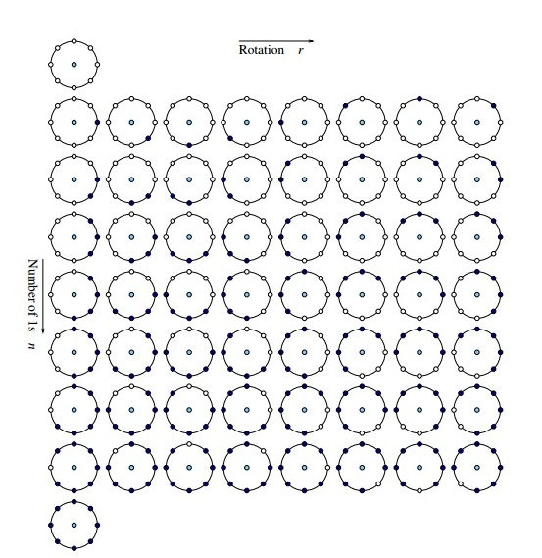

Fig. 9.Uniform Binary Pattern.

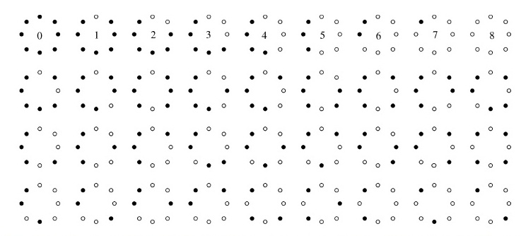

Fig. 10.Rotationally Invariant Uniform Binary Pattern.

1. *Overlapping windows*

Windowing technique is common. Almost all local feature extraction techniques used windowed kernels to extract features. But overlapping kernels are introduced by Tapia et al. [3]. They achieved gender classification of 91% using ULBP with a kernel size, of 10 x 10 with 50%. This 91% is for their selected data. But the trend they suggested for various variants of LBP goes by: ULBP performs better than LBP, Windowing performs better than non–windowing and overlapping windows performs better than non–overlapping windows. This trend was observed to apply even to our data.

Windows extract more information as they are locally fixed around particular region. Similar consequence of overlapping windows suggests: information missed by non–overlapping windows is captured by overlapping windows.

1. *GRAB –Generalized region assigned to binary*

While LBP is invariant to variables like illumination, translation, rotation; it may not be able to handle scale changes. GRAB deals with it by combining micro-structure and global structure, as well as the structure at multiple scales by extracting features at varying scales of the images.

For the simple GRAB operator, with neighbours j = 1,...,n, we let c stand for the centre pixel and j for the neighbour pixel. For each pixel c, we can define the generalized binary representation as:

GRAB operator can be implemented as a generalization of ELBP [18] in the sense that the block averages around the centre pixel can be arranged in circular or elliptical fashion.

This GRAB operator is applied on a Geo-normalized image. First, an averaging operator is applied to the image with the window size of N × N. For each N × N region in the image, the centre pixel of the region, pc, is assigned an average value of that region resulting in a smoothed image. Second, the neighbouring operator is applied to the smoothed image. This operator is the simple LBP operator in either standard numbering or alternate numbering of neighbours.

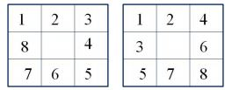

Fig. 11. Standard and Alternative numbering

Here, we apply the averaging operator trice with 3*3, 5*5, and 7*7 window size, and then apply LBP on these images to get the feature set. The GRAB using standard LBP with the alternative numbering scheme produced relatively lower accuracy than that by using ULBP.

## C. Fusion of Features

There are various kinds of fusion to improve a system. Some to mention: fusion of input data, fusion of features, the fusion of classifiers. General purpose of fusion is to describe a system by two or more methods when a stand-alone method fails to capture system details. That is, if a single method captures some part of the system, the other method could capture the other details of the system. Thereby, fusing these two methods will result in better understanding of the system.

In our project we perform feature level fusion. This can be better understood with the help of Fig. 12. That is, we take the top two best performing feature extraction technique and fuse them. Fusing extracted features is by appending one to another. Features resulting from Local Phase Quantization, Local Binary Patter, or Grab are the histogram values. Appending histogram of one feature extraction technique to the other results in higher dimension, but detailed feature vector. This detailed feature vector carries more information of the system and may produce better classification results.

In our experimentation, the top two techniques- ‘Uniform Local Binary Pattern–ULBP with 10 x 10 windowing and 50% overlap’ and ‘GRAB–ULBP with 10 x 10 windowing and 50% overlap’ were fused. This fusion outperformed GRAB–ULBP with 10 x 10 windowing and 50% overlap, producing the best result.

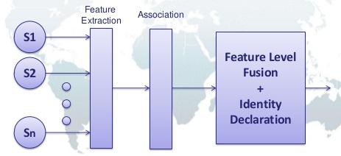

Fig. 12.Feature level fusion.

## D. Choice of Classifier

Different mathematical principles govern the rules of machine learning classifiers. We concentrate on supervised machine learning techniques. After experimenting with different classifiers like Support Vector Machines–SVM, Ensemble, Decision trees, K nearest neighbor–KNN, we found that SVM with linear function resulted in higher classification accuracy.

Most used Machine Learning classifiers are SVM and KNN. KNN is known for its speed, but SVM for its accuracy. In both the techniques n–dimensional feature vectors are represented in n–dimensional space. Thus ‘m’ feature vectors are plotted in n–dimensional space as ‘m’ separate points. As represented by Fig. 13. (Right), K as integer KNN considers K nearest points with respect to the test feature point. Thus the maximum class of K points is the classification result of KNN. Also, KNN produces varied results with variation in K.

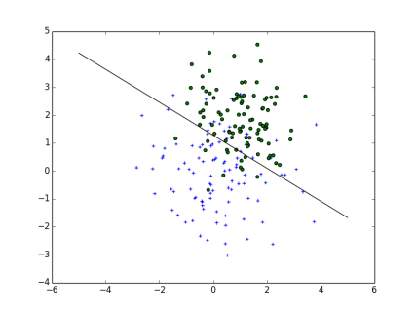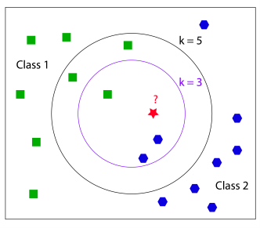

Fig. 13. Left: SVM Classifier and Right: KNN Classifier.

SVM on the other hand tries to separate classes using various functions as shown in Fig. 13. (Left). Usually, Radial Basis function–RBF is deemed to perform better over linear function and Quadratic function. Additionally, Moghaddam and Yang [19] suggested SVM–RBF as the best gender classifier. However, with dimension of feature vector greater than data, RBF may produce false results. With windowing, dimension of feature vectors increases, thus we use SVM with Linear function.

# Experiment

## A. Dataset

Data used for this project are taken from ND–IRIS–0405[7] image dataset. Details of this database are available at: htpp://www3.nd.edu/~cvrl/CVRL/DataSets/hmtl. Images in ND–IRIS–0405 image dataset are captured using LG–2200 imaging system under near-Infrared illumination. Out of the total 356 subjects, 198 are male and the rest are female. Number of images for each subject is not constant. In all, there are over 64,980 images.









Fig. 14.Iris Images from NDIRIS.

Random images couldn’t result in reliable classification accuracy. Therefore, images without anomalies like blur, shadows, extended eyelashes, illumination, eyelids and off–angle (Fig. 14, top three rows) had to be selected manually. Also, in order to describe a subject accurately, both left and right irises of each subject were considered (Fig. 14, last row). Finally, we selected 194 subjects of which 198 are male and the rest are female. The ten images of each subject consist of 5left iris images and 5 right iris images. For cross validation 5 different data sets were produced by mixing. In each set, we selected 4 of the 5 iris images of each subject for training and 1 for testing. With this semi predictable data, better classification results have been achieved.

## B. Procedure

Using a simple local feature extractor without windowing results in a lower dimension feature vector- 255, but it does not extract the local textural features of the image. Thus, using windowing and overlapping, dimension of feature vectors increases. The dimension of each iris template image is 30 x 360. The following table lists dimension of feature vector using the corresponding feature extraction technique.

Table. 1. Feature Dimension for respective extraction algorithm

|  |  |
| --- | --- |
| Feature Extraction Technique | Feature Dimension |
| LPQ – window 10*10 | 5400 |
| LBP - window 10*10 | 27648 |
| LBP - window 10*10 (50 % overlap) | 90880 |
| ULBP – window 10 * 10 | 6372 |
| ULBP – window 10 * 10 (50 % overlap) | 20945 |
| Regular GRAB – window 10*10 | 6480 |
| Regular GRAB – window 10*10 (50 % overlap) | 21300 |
| GRAB with ULBP – window 10*10  (50 % overlap) | 62835 |
| ULBP + GRAB with ULBP – window 10*10  (50 % overlap) | 83780 |

For instance, consider Local Binary Pattern which has 256 bins for each window. With 10 x 10 windowing of 30 x 360 size image, there are 3 x 36 windows of 256 bins. So in all, the dimension of feature vector is 27,648 (3 x 36 x 256). With similar settings, ULBP gives a feature vector of size 6372 (3 x 36 x 59). Similarly GRAB–ULBP with 10 x 10 windowing, we get 6,372 (3 x 36 x 59). But with 50% overlap, we get 29,323 ((3+4) x (36 + 35) x 59).

Further, due to fusion the size of fused feature vector increases, but can be decreased with additional efforts. These varied number of feature dimension helps us extracting the local features along with the relatively global feature of the image. Thereby, various characteristic ridges, edges, corners, non–uniformity in image, are captured by these feature vectors.

1. RESULTS

Table 2 represents the classification results achieved for various Feature Extraction Techniques. LPQ achieves the lowest classification accuracy of 74%for original data and 71% for masked data.

Experimenting with LBP, proves LBP performs better than LPB with 77.5% for original and 72.6% for masked. Further, windowing of 50%increases the performance of LBP to 80.6%and 76.2%respectively.

Table. 2. Classification Results for respective extraction algorithm

|  |  |  |  |  |
| --- | --- | --- | --- | --- |
| Feature Extraction Technique | | Original | Masked | |
| LPQ – window 10*10 | 74 % | | 71% |
| LBP - window 10*10 | 77.5 % | | 72.6 % |
| LBP - window 10*10 (50 % overlap) | 80.6 % | | 76.2 % |
| Regular GRAB – window 10*10 | 79 % | | 75 % |
| Regular GRAB – window 10*10  (50 % overlap) | 83 % | | 80 % |
| ULBP – window 10 * 10 (50 % overlap) | 86.4 % | | 82.2 % |
| GRAB with ULBP –  window 10*10 (50 % overlap) | 87.6 % | | 84.3 % |
| ULBP + GRAB with ULBP –  window 10*10 (50 % overlap) | 88.4 % | | 86 % |

GRAB, higher resolution implementation of LBP achieved an accuracy of 79% for original and 75% for masked. This is higher than that of normal LBP. Then, we tried similar windowing and overlapping on GRAB and results improved to 83% for original and 80% for masked.

Similarly, ULBP with reduced dimension of LBP performed better than LBP. However, with windowing and overlapping ULBP achieved an accuracy of 86.4% for original and 82.2% for masked, which is higher than GRAB.

Therefore, this led us to believe, GRAB implemented using ULBP instead of LBP would extract more information. It proved to be true in our results, with 86.4% for original and 82.2% for masked data.

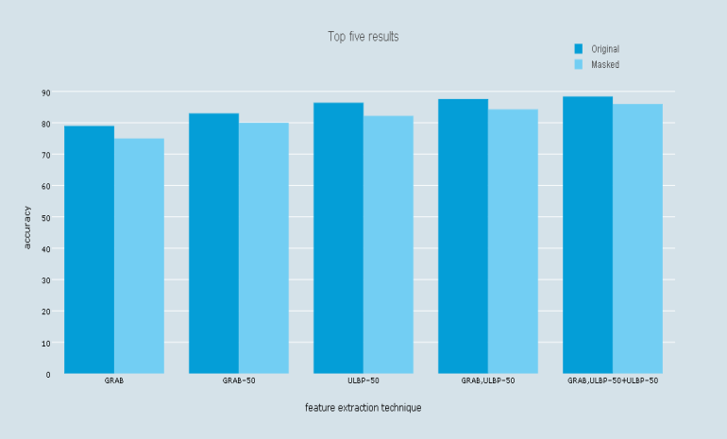

Fig. 15.Plot of Top Five Classification Results.

With the idea of fusion, the top two results of windowed, overlapped ULBP and windowed, overlapped GRAB–ULBP features were concatenated. This further increased accuracy to with 87.6% for original and 84.3% for masked, resulting in possibly the best method to extract iris features till date. Fig.15 shows graph representing the top five results obtained.

# CONCLUSION

To our knowledge, this paper is the first to implement GRAB using ULBP and also first to achieve highest accuracy with a fusion of GRAB with ULBP and ULBP in iris classification based on gender. With this, we believe, we have yet another variant of LBP with accuracy higher than other existing LBP variants.

We also masked a common region of all iris templates so as to account for the obstructions due to eyelids and eyelashes in majority of iris images. Even though, masking did not produce accuracy higher than otherwise, we believe masking reduced false-positive classification.

According to us, a fusion of pixel level features and higher resolution features will achieve higher results than standalone. To generalize, we believe various levels of resolution features will describe the data at its best. This in turn will help in the manipulation, representation or classification of data.

With the aim to advance iris gender classification system, we plan to carry out additional experiments. Henceforth, our next focus will be to achieve iris classification results for left and right iris separately. Also, classification results for different ethnic groups will be studied to choose the best classification method for each race.

# ACKNOWLEDGMENT

Thanks to Biometric and Pattern Recognition Lab Director: Dr. Damon Woodard for constantly motivating and supporting us. Thanks to previous researcher, contributing to Gender classification using Iris, Iris Segmentation and Iris data collection. Furthermore, we would also like to thank Mr. Sushant Surendra for helping us in refining the NDIRIS dataset.

# REFERENCES

1. A.Bansal, R. Agarwal, and R.K. Sharma. Predicting gender using iris images. In Res. J. Recent Sci., volume 3(4), pages 20–26. International Science Congress Association, April 2014.
2. S. Lagree and K.W. Bowyer. Predicting ethnicity and gender from iris texture. In Technologies for Homeland Security (HST), 2011 IEEE International Conference on, pages 440–445. Nov 2011.
3. Juan E. Tapia, Claudio A. Perez, and Kevin W. Bowyer. Gender classification from iris images using fusion of uniform local binary patterns. In Lourdes Agapito, Michael M. Bronstein, and Carsten Rother, editors, Computer Vision - ECCV 2014 Workshops, volume 8926 of Lecture Notes in Computer Science, pages 751–763. Springer International Publishing, 2015.
4. V. Thomas, N.V. Chawla, K.W. Bowyer, and P.J. Flynn. Learning to predict gender from iris images. In Biometrics: Theory, Applications, and Systems, 2007. BTAS 2007. First IEEE International Conference on, pages 1–5. Sept 2007.
5. Sapkota, Parks, Scheirer, Boult. FACE-GRAB: Face Recognition with General Region Assigned to Binary Operator. Preprint of paper to appear atIEEE Biometrics Workshop at CVPR, 2010.
6. Sapkota and Boult. GRAB: generalized region assigned to binary. In EURASIP Journal on Image and Video Processing, Springer International Publishing 2013.
7. Kevin W. Bowyer and Patrick J. Flynn. The ND-IRIS-0405 iris image dataset. Computer Vision Research Lab, University of Notre Dame.
8. Christian Rathgeb, Andreas Uhl, Peter Wild. USIT Software, University of Salzburg Nov 2012.
9. Nanni, Loris and Brahnam, Sheryl and Lumini, Alessandra. Local Phase Quantization Descriptor for Improving Shape Retrieval/Classification. Pattern Recogn. Lett. December, 2012.
10. Libor Masek, P. Kovesi. Matlab source code for a biometric identification system based on iris patterns. The School of Computer Science and Software Engineering, the University of Western Australia. (2003)
11. P. J. Phillips, K. W. Bowyer, P. J. Flynn, X. Liu, and W. T. Scruggs, The iris challenge evaluation 2005, in 2nd IEEE International Conference on Biometrics: Theory, Applications and Systems, 2008, pp. 1-8.
12. Uhl, Wild. "Weighted adaptive Hough and Ellipsopolar transforms for real-time iris segmentation," in Biometrics (ICB), 2012 5th IAPR International Conference on , vol., no., pp.283-290, March 29 2012-April 1 2012
13. Ojala T. and Pietikäinen M &MäenpääT. Multi resolution gray scale and rotation invariant texture classification with Local Binary Patterns. 2002 IEEE Transactions on Pattern Analysis and Machine Intelligence 24(7):971 - 987.
14. Ojala T. and Pietikäinen M and Mäenpää T. A generalized Local Binary Pattern operator for multiresolution gray scale and rotation invariant texture classification. 2001 In: Advances in Pattern Recognition, ICAPR 2001 Proceedings, Lecture Notes in Computer Science 2013, Springer, 397 – 406.
15. Ahmed, F.; Hossain, E.; Bari, A.S.M.H.; Shihavuddin, A. Compound local binary pattern (CLBP) for robust facial expression recognition. Computational Intelligence and Informatics (CINTI), 2011 IEEE 12th International Symposium on.
16. Di Huang, Caifeng Shan, Mohsen Ardabilian, Yunhong Wang and Liming Chen, “Local Binary Patterns and Its Application to Facial Image Analysis: A Survey,” IEEE Transaction on Systems, Man and Cybernetics-part C: Applications and Reviews, vol.41, no.6, pp. 765-781, Nov 2011.
17. Ahonen, Timo and Matas, [JiříMatas](http://dl.acm.org/author_page.cfm?id=81100444935&coll=DL&dl=ACM&trk=0&cfid=568094232&cftoken=26952125) and He, Chu and  [MattiPietikäinen](http://dl.acm.org/author_page.cfm?id=81100016822&coll=DL&dl=ACM&trk=0&cfid=568094232&cftoken=26952125). Rotation Invariant Image Description with Local Binary Pattern Histogram Fourier Features. Proceedings of the 16th Scandinavian Conference on Image Analysis. SCIA '09 2009. 978-3-642-02229-6. Oslo, Norway.
18. Liu, Li and Zhao, Lingjun and Long, Yunli and Kuang, Gangyao and Fieguth, Paul. Extended Local Binary Patterns for Texture Classification. Image Vision Computer, February, 2012
19. Yang, M.H., Moghaddam, B.: Gender classification using support vector machines. Proc. Int. Image Processing Conf 2 (2000) 471 –474.

1.